The Islamia University of Bahawalpur
Department of Information Technology
Faculty of Computing



Software Requirement Specification (SRS)
for

Pesticide Shop Management System

Version 1.0

By
Ali Raza
S23BINFT1M01122
Session Spring 2023 – 2027
Supervisor
Mr Zaman Ali
Bachelor of Science in Business Administration

Revision History

Name | Date | Reason for changes | Version

Document Approval
The following Software Requirements Specification has been accepted and approved by the following:
Signature | Printed Name | Title | Date

Application Evaluation History

Comments (by committee)  *include the ones given at scope time both in doc and presentation | Action Taken

Supervised by
Mr Zaman Ali
Signature______ _____

Table of Contents

1. Introduction 1
1.1 Purpose 1
1.2 Scope 1
1.3 Definitions, Acronyms, and Abbreviations. 1
1.4 References 1
1.5 Overview 1
2. The Overall Description 2
2.1 Product Perspective 2
2.1.1 Operations 2
2.1.2 Site Adaptation Requirements 3
2.2 Product Functions 3
2.3 User Characteristics 3
2.4 General Constraints 4
2.5 Assumptions and Dependencies 4
3. Specific Requirements 4
3.1 External Interface Requirements 5
3.1.1 System Interfaces 5
3.1.2 Interfaces 5
3.1.3 Hardware Interfaces 5
3.1.4 Software Interfaces 5
3.1.5 Communications Interfaces 6
3.2 Functional Requirements 6
3.2.1 <Functional Requirement or Feature #1> 6
3.2.2 <Functional Requirement or Feature #2> 7
3.3 Use Cases 7
3.3.1 Use Case #1 7
3.3.2 Use Case #2 7
3.4 Classes / Objects 7
3.4.1 <Class / Object #1> 7
3.4.2 <Class / Object #2> 7
3.5 Non-Functional Requirements 7
3.5.1 Performance 8
3.5.2 Reliability 8
3.5.3 Availability 8
3.5.4 Security 8
3.5.5 Maintainability 8
3.5.6 Portability 8
3.6 Inverse Requirements 8
3.7 Logical Database Requirements 8
3.8 Design Constraints 8
3.8.1 Standards Compliance 8
4. Analysis Models 9
4.1 Sequence Diagrams 9
4.2 Data Flow Diagrams (DFD) 9
4.3 State-Transition Diagrams (STD) 9
5. Supporting Information 9
Appendix A – Background Research on: 9
Appendix B – Data Dictionary 9

1. Introduction
The Pesticide Shop Management System is a software application developed with Python and tkinter as the user interface tool. It has been designed for everyday operations in pesticide shops operated by agricultural firms. The software goes towards settling many ticklish points of business in a shop. It provides a user-friendly interface and allows administrators and users to login separately. In effect, it manages products, completes bills and records sales in a more efficient way so as to lighten your day-to-day operations and improve order for your customers.

1.1 Purpose
My goal is to design a desktop application that is both secure and user-friendly, allowing administrators and shop staff to log in based on their designated roles.
The application will have automated inventory management capabilities that will allow users to easily add new pesticide products and keep track of real-time stock levels, as well as being able to send automated low-stock alerts to avoid running out.
BILLINGAPPLICATIONThis application will be easy to use for billing purposes. It should enable fast product selection, complete pre-calculations of costs, including tax and discounts, and ultimately printing out invoices.

1.2 Scope
This system includes a program for managing products, billing, and recording sales in pesticide shops. The system simplifies many daily tasks and reduces error. The system includes login for admin and users, and is designed to be used only on a desktop PC using Python and the tkinter library.

1.3 Definitions, Acronyms, and Abbreviations.
Term / Acronym | Full Form / Definition
SRS | Software Requirements Specification; a document that describes what the pesticide shop management system must do and its operational constraints
Pesticide Shop Management System | A desktop-based software developed using Python and tkinter to manage products, billing, and sales in pesticide shops
Python | A high-level programming language used to develop the system logic and functionality
Tkinter | A standard Python library used to create the graphical user interface (GUI) of the system
Desktop Application | A software application that runs locally on a computer without requiring a web browser
Inventory Management | The process of tracking and managing pesticide products, stock levels, and availability
Billing System | A feature that generates invoices and records customer purchases efficiently
Sales Management | The process of recording, tracking, and analyzing sales transactions
User | A person who accesses the system to perform daily shop operations like billing and viewing products
Admin | An authorized user responsible for managing products, users, and overall system settings
Product | Pesticide items stored in the system with details such as name, price, and quantity
Dashboard | The main interface that displays system summary, sales details, and quick access to features
Database | A structured collection of data used to store product details, user information, and sales records
Authentication | The process of verifying user identity through login credentials
Authorization | The process of granting access rights based on user roles (admin or user)
Performance | The ability of the system to handle operations quickly and efficiently
Security | Measures taken to protect system data from unauthorized access or misuse
Term / Acronym | Full Form / Definition
SRS | Software Requirements Specification; a document that describes what the system must do and the constraints under which it must operate
Digital Marketing Services | A web-based software system that provides, manages, and delivers digital marketing solutions through an online platform
PHP | Hypertext Preprocessor; a server-side scripting language used to develop the web-based Digital Marketing Services system
Web Application | A software application that runs on a web server and is accessed through a web browser
SEO | Search Engine Optimization; techniques used to improve a website’s visibility on search engines
SMM | Social Media Marketing; the use of social media platforms to promote products or services
Content Management | The process of creating, editing, organizing, and publishing digital content through the system
Online Advertising | Digital promotion of products or services using paid ads on search engines or social media platforms
Client | A user who accesses the system to view services, submit requests, or manage marketing campaigns
Admin | An authorized user responsible for managing services, users, content, and system settings
Campaign | A planned set of digital marketing activities designed to achieve specific business goals
Dashboard | A web interface that displays summarized information, analytics, or system status to users or administrators
Database | A structured collection of data used to store user information, service details, and campaign data
Authentication | The process of verifying the identity of a user accessing the system
Authorization | The process of granting users permission to access specific features or resources
Performance | The ability of the system to respond efficiently and handle user requests within acceptable time limits
Security | Measures implemented to protect system data from unauthorized access or misuse

1.4 References
No. | Document Title | Report No. / Version | Date | Publishing Organization | Source
1 | IEEE Standard for Software Requirements Specification | IEEE 830-1998 | 1998 | IEEE | https://standards.ieee.org
2 | ISO/IEC/IEEE Systems and Software Engineering — Life Cycle Processes | ISO/IEC/IEEE 12207 | 2017 | ISO / IEEE | https://www.iso.org
3 | Python Official Documentation | Python 3.x | Latest | Python Software Foundation | https://docs.python.org
4 | Tkinter GUI Documentation | Tkinter (Python GUI Library) | Latest | Python Software Foundation | https://docs.python.org/3/library/tkinter.html
5 | SQLite / Database Documentation | SQLite 3.x | Latest | SQLite Organization | https://www.sqlite.org/docs.html
6 | HTML Living Standard | HTML5 | Latest | WHATWG | https://html.spec.whatwg.org
7 | CSS Specifications | CSS3 | Latest | W3C | https://www.w3.org/Style/CSS/
This section provides a complete list of documents and resources referenced in the Software Requirements Specification (SRS) for the Pesticide Shop Management System These documents offer standards, technical background, and supporting information relevant to understanding the requirements of the system. All references are publicly available and can be obtained from the sources specified below.

1.5 Overview
This system uses Python’s tkinter library to design the User Interface (UI) of the Pesticide Shop Management System. It is simple and sleek and includes two desktop applications, one for the admin and other for normal users. Each desktop application has its own set of shortcuts to directly navigate to the product management, billing, and sales records modules.

2. The Overall Description
This system uses Python’s tkinter library to design the User Interface (UI) of the Pesticide Shop Management System. It is simple and sleek and includes two desktop applications, one for the admin and other for normal users. Each desktop application has its own set of shortcuts to directly navigate to the product management, billing, and sales records modules.
Products and buttons have been clearly labelled and user can add / update / delete products, make bills and sales with ease. All pop-up messages and field validation alerts are designed to help user complete the tasks in a correct manner. The UI is highly usable, easy to understand and accessible to people with minimal computer skills. It enables shop owner and owner's family members to manage daily activities of the shop efficiently.
Menus, search, tables are organically structured for quick access to commonly used functions. In general, intuitive, responsive, efficient interface makes work in pesticide shops more productive and convenient for shop employees and for their customers.

2.1 Product Perspective
User Management The login system is password-protected and can be divided into administrative and shop employee permissions.
Product Management – Add, update, and manage pesticide products with detailed information.
Stock Management – Track the stock in real time and update the quantity of products automatically.
Low Stock Alerts – Alerts sent automatically to you when the stock reaches a minimum quantity level.
BILLING SYSTEM The billing system allows users to generate bills for their customers by selecting the products needed. The system is programmed to calculate the prices of the selected products and add them to the bill automatically.

2.1.1 Operations
This system is very easy to use. It is built using tkinter, which is a language and high-level graph. It is designed for the shop staff with little or no technical knowledge. It has simple navigation with buttons and forms for users to add, update products, make bills and view all the past sales details. Both admin and normal users will find it very easy to and less error prone to use.
The system is built entirely using Python for the backend, and it handles the processing of the data as well as generating the bill accordingly. All the product and sales information is stored in a database, where the Python backend communicates with in order to process the information. It is pretty much designed for a simple application to interact with the UI and the database

2.1.2 Site Adaptation Requirements
User Management The login system is password-protected and can be divided into administrative and shop employee permissions.
Product Management – Add, update, and manage pesticide products with detailed information.
Stock Management – Track the stock in real time and update the quantity of products automatically.
Low Stock Alerts – Alerts sent automatically to you when the stock reaches a minimum quantity level.
BILLING SYSTEM The billing system allows users to generate bills for their customers by selecting the products needed. The system is programmed to calculate the prices of the selected products and add them to the bill automatically.
Tax & Discount Calculations – Bills will automatically calculate the tax and discount amounts.
Printable Invoices – Create invoices ready to print for the customers.
Sales Records – All completed sales should be stored permanently in the system database.
Search Functionality – Be able to search through past sales by date, product names, and customer information.
Sales Reports – View the overall sales summaries and analysis reports.

2.2 Product Functions

Product Management Module
Admin can manage stock and keep in stock products that are needed for daily shop operations. This module helps to keep track of inventory so you won't run out of products you need and won't overstock products that don't sell as well.

Billing Module
The billing module generates invoices for all customer purchases, calculates and applies the prices and keeps track of the transactions. You can easily make or print a bill for a customer purchase in the shop, and this module helps to avoid errors associated with manual calculation and can save a lot of time.

Sales Management Module
Sales monitor records and manages all the sales that are made in the shop, tracking the daily, weekly and monthly sales for reference. It allows users to view past sales records and track the shop's performance to make better business decisions.

Database Management Module
This module is responsible for storing and retrieving information such as products, users and sales data. It ensures all stored information is arranged and kept in a consistent format. The database is able to efficiently handle queries allowing for smooth functioning of the site. The database also maintains data integrity.

User Management Module
This is where the login to the app and user account administration from the admin interface actually happens. Admin users can add, edit or delete new user accounts and these users can be assigned to roles such as admin and user. Each role then has a certain set of permissions and can access certain sensitive features while being locked out of others. An essential function in securing and accounting for the entire system.

2.3 User Characteristics
The system is designed with user-friendliness in mind. Throughout the system users are able to jump between the product management module and the billing module amongst others. Using a straightforward user interface and clear function buttons the system has kept the amount of actions users have to complete to a minimum. While the platform can be fully utilised by a non-technical user, system administrators can also configure complex rules that control access and actions.
The system is configured for easy use and all interactions are handled through a responsive desktop interface. The interface adjusts itself so that all features can be interactively accessed regardless of window size and desktop resolution. Although non-web based, it is cleverly designed to ensure all features are fully accessible without any changes to the layout or anomalies (unlike traditional Tkinter systems).

2.4 General Constraints
This system is very easy to use. It is built using tkinter, which is a language and high-level graph. It is designed for the shop staff with little or no technical knowledge. It has simple navigation with buttons and forms for users to add, update products, make bills and view all the past sales details. Both admin and normal users will find it very easy to and less error prone to use.
The system is built entirely using Python for the backend, and it handles the processing of the data as well as generating the bill accordingly. All the product and sales information is stored in a database, where the Python backend communicates with in order to process the information. It is pretty much designed for a simple application to interact with the UI and the database.
Even though the system currently does not require a log in, it does keep track of sessions and currently there are 2 different roles, Admin and User. Even when making changes to the system, the information is always stored within the database and cannot be changed unintentionally. Our goal was to create a basic secure system but with optimal usability and efficiency. The owner and employees of your business will find the system very easy to utilize, while at the same time your businesses information will be secure

2.5 Assumptions and Dependencies
This program assumes the user has some basic knowledge of computers and is operating off of a desktop platform. It also assumes the user has Python and tkinter installed on their computer. The system also requires a local database where the product, user, and sales information will be stored. The system will not work without the proper input of the user and updated information. It does not require an internet connection to run and depends heavily on reliable hardware.

3. Specific Requirements
The software should include an option for creating pesticide products, making bills and sales quickly. It should also have an option for user login with admin and staff accounts with different access rights. Users should be able to add, modify or delete the details of a product, search and filter products. The system must ensure of accurate, instantaneous and secure data management by utilizing a local database system.

3.1 External Interface Requirements

3.1.1 System Interfaces

No. | External System / Device | Functionality Supported | Interface Description
1 | Desktop Application Interface | Provides user access to the system for managing products, billing, and viewing sales records | The system uses a tkinter-based GUI with forms, buttons, and dashboards for smooth interaction on desktop systems
2 | Display / Monitor | Displays product details, billing information, and sales reports to users and administrators | The system outputs data through a graphical user interface with tables and labels for clear visualization
3 | Database / Data Storage | Stores user accounts, product details, billing records, and sales data | The system reads and writes data using a local database (e.g., SQLite) with structured queries and secure access
4 | Printer (Optional) | Prints customer bills and reports generated by the system | The system sends formatted billing data to connected printers for physical copies of invoices
5 | Operating System | Provides runtime environment for executing the Python application | The system runs on compatible operating systems (Windows/Linux) supporting Python and tkinter libraries
6 | File System / Storage | Saves backup files, reports, and system logs | The system interacts with local storage to save and retrieve files securely for future reference

3.1.2 Interfaces
This system uses Python’s tkinter library to design the User Interface (UI) of the Pesticide Shop Management System. It is simple and sleek and includes two desktop applications, one for the admin and other for normal users. Each desktop application has its own set of shortcuts to directly navigate to the product management, billing, and sales records modules.
Products and buttons have been clearly labelled and user can add / update / delete products, make bills and sales with ease. All pop-up messages and field validation alerts are designed to help user complete the tasks in a correct manner. The UI is highly usable, easy to understand and accessible to people with minimal computer skills. It enables shop owner and owner's family members to manage daily activities of the shop efficiently.
Menus, search, tables are organically structured for quick access to commonly used functions. In general, intuitive, responsive, efficient interface makes work in pesticide shops more productive and convenient for shop employees and for their customers.

3.1.3 Hardware Interfaces
This system can run on any hardware that has a desktop or laptop with enough RAM and Processing capacity to run Python and tkinter based software. A keyboard and mouse will be required to interact with the system. One or more monitors will display the graphical interface to the user. Optional printers can be connected to the system to print the bills as well as reports.

3.1.4 Software Interfaces

No. | Name | Mnemonic | Specification / Doc No. | Version | Source
1 | PHP | PHP | PHP Language Reference | 8.x+ | PHP Group (https://www.php.net)
2 | MySQL | SQL | MySQL Reference Manual | 8.x | Oracle Corporation (https://dev.mysql.com/doc/)
3 | HTML / CSS / JavaScript | HTML/CSS/JS | W3C Specifications | Latest | W3C (https://www.w3.org)
4 | Optional Messaging API | MSG | Vendor API Documentation | Latest | Twilio / SMTP Server (https://www.twilio.com)
5 | Optional Analytics / Reporting Libraries | LIB | Library Documentation | Latest | Chart.js, Google Charts, or similar (https://www.chartjs.org)

3.2 Functional Requirements
This section describes specific features of the software project. If desired, some requirements may be specified in the use-case format and listed in the Use Cases Section.
Subsection | Description
3.2.1.1 Introduction | This function allows users to manage pesticide products, generate bills, and record sales transactions. It ensures that all shop operations are handled efficiently through a user-friendly desktop interface, improving accuracy and reducing manual work in daily activities.
3.2.1.2 Inputs | User inputs entered through the graphical interface such as product details, billing information, and login credentials. Data includes product name, price, quantity, and customer purchase details.
3.2.1.3 Processing | The system validates user inputs and processes operations such as product management, bill generation, and sales recording. Data is stored and retrieved from the local database. Calculations for billing and updates to inventory are performed automatically by the system.
3.2.1.4 Outputs | The system displays confirmation messages, updated product lists, generated bills, and sales reports through the interface. It may also provide printable invoices and summarized sales information for users and administrators.
3.2.1.5 Error Handling | Invalid inputs, missing data, or system errors trigger appropriate error messages on the screen. The system ensures users are informed of issues and prevents incorrect data entry. Errors can be logged for troubleshooting and system maintenance by the administrator.

Product Management Function
Subsection | Description
Introduction | This function allows the admin to manage pesticide products by adding, updating, deleting, and viewing product details. It helps maintain accurate inventory and ensures product availability in the shop.
Inputs | Product details entered by the user such as product name, category, price, and quantity.
Processing | The system validates input data and performs operations like storing, updating, or deleting product records in the database.
Outputs | Updated product list displayed on the screen with confirmation messages.
Error Handling | Displays error messages for invalid or missing product data and prevents incorrect entries.

Billing Function
Subsection | Description
Introduction | This function enables users to generate bills for customer purchases quickly and accurately. It reduces manual calculations and improves efficiency.
Inputs | Selected product details, quantities, and pricing information entered during billing.
Processing | The system calculates total cost, updates stock, and stores billing records in the database.
Outputs | Generated bill displayed on screen with total amount and option to print.
Error Handling | Shows errors for invalid inputs, insufficient stock, or missing data.

Sales Management Function
Subsection | Description
Introduction | This function manages and records all sales transactions, helping track business performance over time.
Inputs | Sales data including bill ID, date, and total amount.
Processing | The system stores and organizes sales records in the database for future retrieval and analysis.
Outputs | Displays sales history and summaries such as daily or monthly sales.
Error Handling | Prevents duplicate or incorrect entries and shows error messages when needed.

Reporting & Analytics
Subsection | Description
Introduction | This function generates reports related to sales and inventory, helping users analyze business performance.
Inputs | Data retrieved from sales and product records based on selected criteria.
Processing | The system processes and organizes data into meaningful reports.
Outputs | Displays reports such as sales summaries and inventory status.
Error Handling | Handles missing or incorrect data and shows appropriate error messages.

3.3 Use Cases
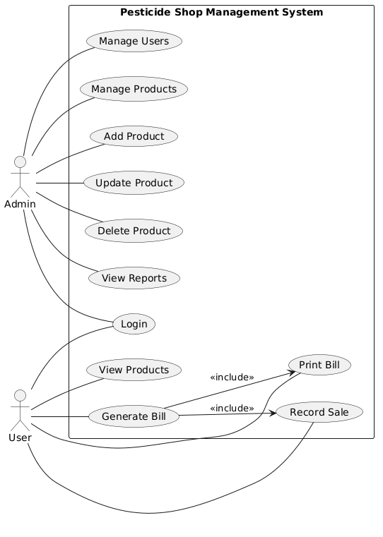

3.4 Classes / Objects
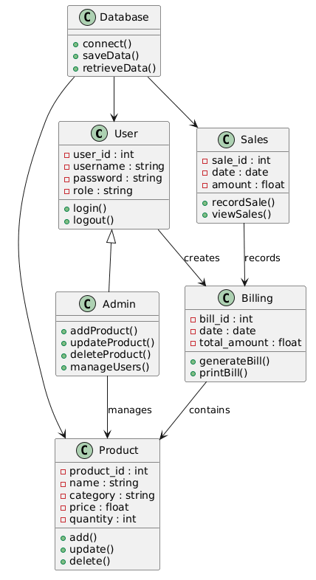

3.5 Non-Functional Requirements
The system should have an easy to use interface with clear navigation path for users with minimal computer skills. System should respond promptly and process billing and products in less than a few seconds. The system should be secured with user authentication and role based access right management.

3.5 Non-Functional Requirements

3.5.1 Performance
System must respond and function properly during use for product management, billing and reporting of sales on a daily basis. System should respond within a few seconds. System is designed to be fast enough to be run from a standard desktop computer without specialized hardware or internet connection.

3.5.2 Reliability
Reliability - The system should always work as expected, performing all needed functions without failure. The system should always correctly store and retreive data in the database. Where possible, backup capabilites and correct error handling will improve system reliability for regular shop activities.

3.5.3 Usability
The system should include user-friendly interface functionality simple for even the most inexperienced user to operate and understand. Clear navigation, clearly numbered pushbuttons and a well laid out and logical layout should facilitate simple and efficient performance of functions. Simple to learn and use without excessive training.

3.5.4 Security
Data security is provided by user authentication and role based access control, meaning users only get access to product management and user settings they are authorised to access. Data stored in the system is secured so that no other programmes can access this data and the system securely stores login details.

3.5.5 Maintainability
The system should be relatively easy to maintain/upgrade. It should have a modular structure so that it is possible to update or modify certain parts or features of the system without affecting other components of the system. The code should also have good documentation, so that it is easy to debug, fix bugs, and make improvements in the long run.

3.5.6 Portability
The code should be able to be ported to any desktop environment with minimal changes, it can currently run on Windows and Linux because we are using Python and tkinter. Any operating system which supports running Python and using tkinter should also support the code. Essentially any operating system which supports running Python should support this code.

3.7 Logical Database Requirements
Entity | Description | Key Attributes | Frequency of Use | Access Capabilities
User | Stores information about system users (admin and staff) who operate the pesticide shop system | user_id, username, password, role | Medium (login and account management) | Read/Write by admin; Read by user for own account
Product | Stores details of pesticide products available in the shop inventory | product_id, name, category, price, quantity | High (inventory management and billing) | Read/Write by admin; Read by system during billing
Bill | Stores billing information generated during customer purchases | bill_id, date, total_amount | High (daily billing operations) | Read/Write by user/admin
Bill_Details | Stores detailed information of items included in each bill | detail_id, bill_id, product_id, quantity, price | High (each transaction) | Read/Write by system
Sales | Stores records of all completed sales transactions | sale_id, date, amount | Medium/High (reporting and analysis) | Read/Write by system/admin
Database | Central storage for all system data including users, products, and sales | tables, records, queries | Continuous (system-wide operations) | Read/Write by system only

3.7 Design Constraints

2.3.1 Visual Design
The user interface was created using tkinter, keeping to a simple design to make it easy to read and use. All text fields, entry fields, buttons and labels were properly aligned with appropriate spacing between each other to maintain a professional and user friendly interface.

2.3.2 User Experience (UX)
The system is designed with user-friendliness in mind. Throughout the system users are able to jump between the product management module and the billing module amongst others. Using a straightforward user interface and clear function buttons the system has kept the amount of actions users have to complete to a minimum. While the platform can be fully utilised by a non-technical user, system administrators can also configure complex rules that control access and actions.

2.3.3 Responsive Interface
The system is configured for easy use and all interactions are handled through a responsive desktop interface. The interface adjusts itself so that all features can be interactively accessed regardless of window size and desktop resolution. Although non-web based, it is cleverly designed to ensure all features are fully accessible without any changes to the layout or anomalies (unlike traditional Tkinter systems).

2.3.4 Security
Security is always a priority, as login and role-based access control to the different functions ensure that only the authorized individual can access the specific features you need to. Functions like updating of products and user management are locked down to the administrators as well to further secure the environment. In a shop environment, you can rest assured that your data is safe.

2.3.5 Performance
The system is designed to function very efficiently in the daily operations of a shop. User commands are processed instantly, bills are generated immediately and required information retrieved speedily. Since it is a desktop application, the system does not require internet connection. Therefore, it can be designed to function perfectly well on a medium range computer hardware.

4. Analysis Models
Several analysis models have been developed to provide a clear understanding of the functional and non-functional requirements of the Pesticide Shop Management System system and to support traceability throughout the SRS. These models include use case diagrams, class diagrams, sequence diagrams, entity-relationship (ER) diagrams, and state transition diagrams.
- The use case diagram identifies interactions between external actors, such as users, administrators, and external services (e.g., email, analytics APIs), with the system, providing a visual representation of all primary functionalities, including service browsing, campaign management, user management, reporting, notifications, and system configuration.
- The class diagram captures the static structure of the system, showing major classes such as SystemController, User, Campaign, ServiceManager, Analytics, NotificationManager, and Logger, along with their relationships. This allows developers to trace each class to the functional requirements it supports.
- Sequence diagrams illustrate the flow of operations for critical functions, such as creating campaigns, updating analytics, sending notifications, or generating reports, showing the order of interactions between classes and external entities.
- The ER diagram represents the logical data model, identifying data entities, attributes, and relationships for users, campaigns, services, metrics, and alerts, providing a foundation for database design and ensuring traceability to data storage and retrieval requirements.
- State transition diagrams model the dynamic behavior of key system components, such as campaign states (draft, active, completed) and notification sequences, ensuring all possible system states and transitions are accounted for in functional requirements.
Together, these analysis models form a comprehensive framework that supports the derivation, validation, and traceability of all requirements documented in this SRS, providing developers and stakeholders with a clear understanding of system behavior, interactions, and expected operations.

4.1 Sequence Diagrams
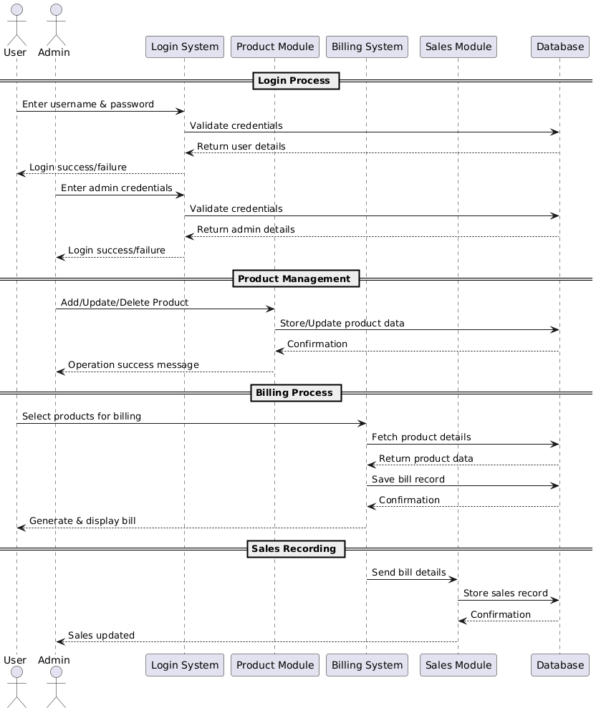

4.2 Data Flow Diagrams (DFD)

Level 0
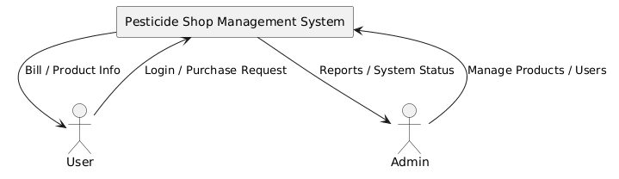

5. Supporting Information
The Pesticide Shop Management System is a Desktop management system that helps you track and manage your daily shop operations for any type of pesticide and agricultural supplies shop. The system allows you to manage your inventory of products and services, generate and print customer bills for each transaction, and record every sales transaction made on a daily basis. Product information, user accounts, billing records, and all of your sales data are efficiently organized and stored for future reference and report generation.
Our design solutions emphasize usability, reliability and maintainability so that people with minimal training can perform simple tasks like adding products, paying for them and tracking their sales. The system is complemented with secure login features to administer users and assign privileges to administrators and regular users. We have made provisions for other non-functional requirements such as performance, accuracy, security and reliability to make the system just right for a retail shop.

